Configure OIM notification

Enable UMS

Login to EM->User Messaging Server->System MBean Browser ->

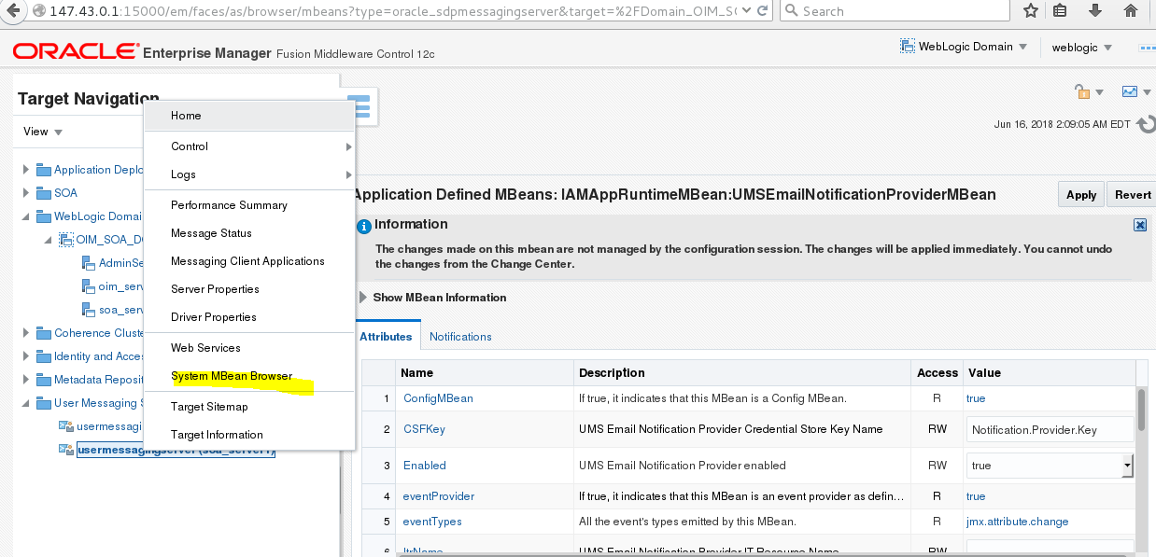

Application defined Mbean -> oracle.iam->Imap Run time Bean->UMS email notification Provider

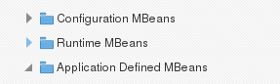

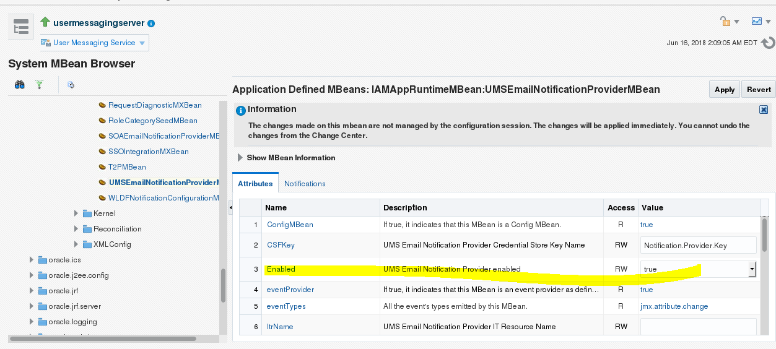

**OIM Notification**

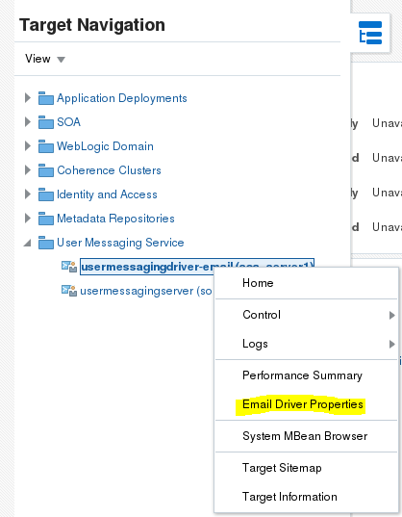

**Set the email properties**

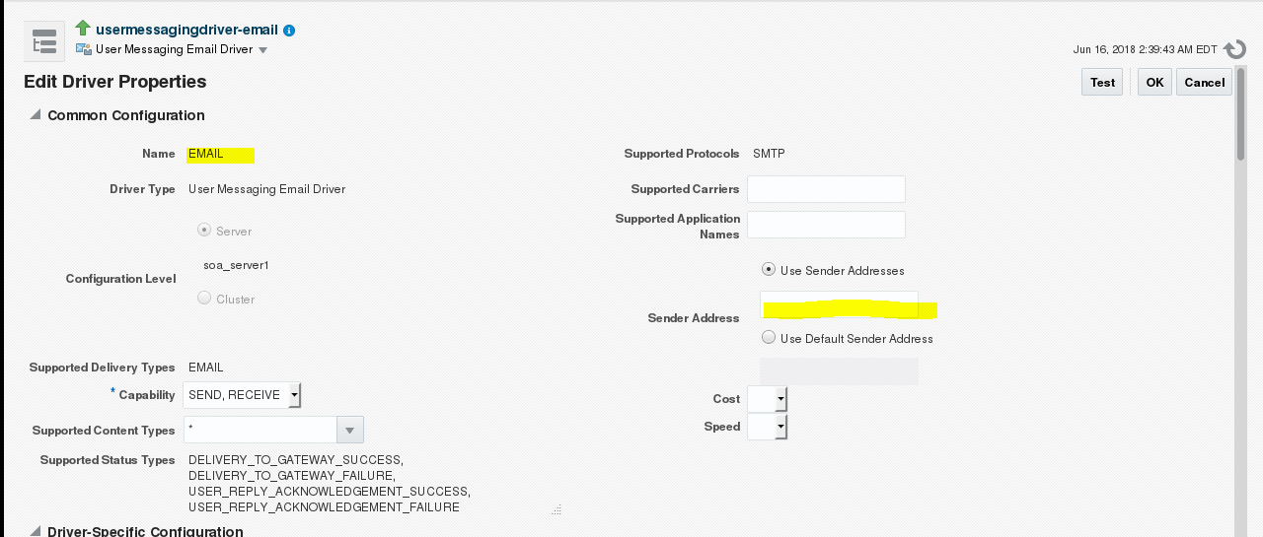

**Set Outgoing and incoming email server details**

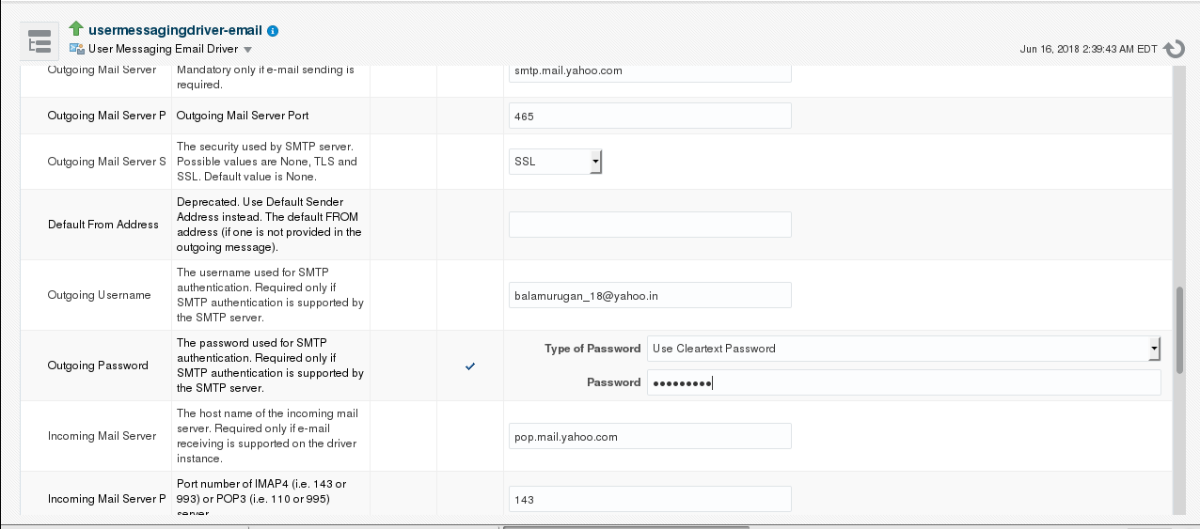

**Reset the password and check whether you received email**

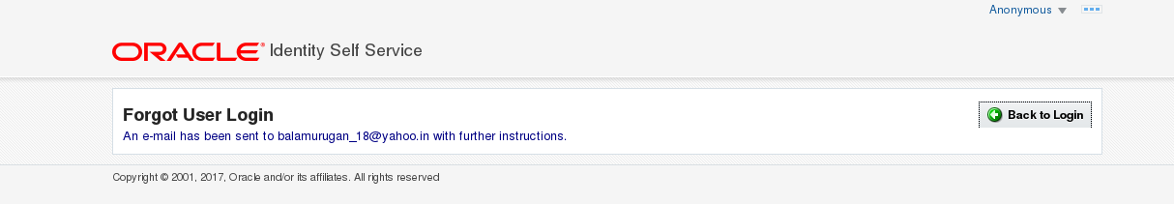

**Error (connection refused)**



**Bounce UMS**

**Configure SOA actionable notification**

**Navigate to Soa infra -> SOA Admin -> WF properties**

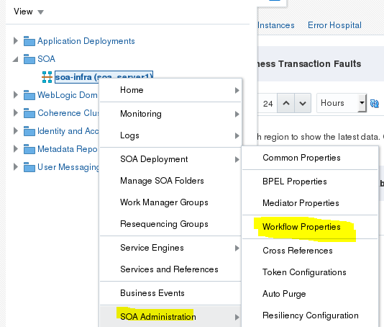

**Set the actionable email address and apply**

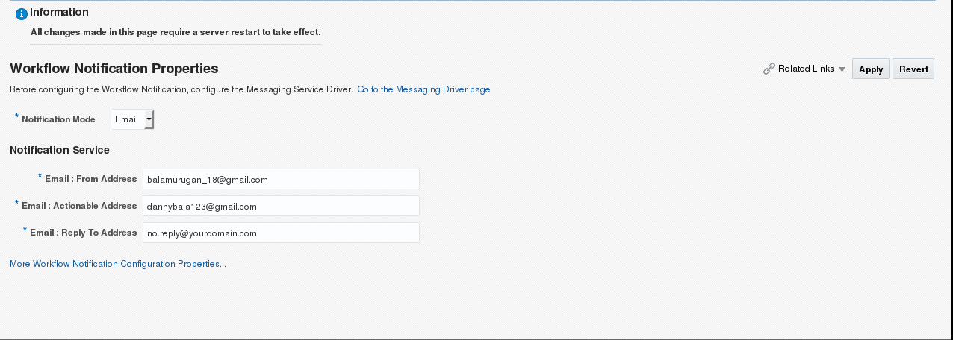

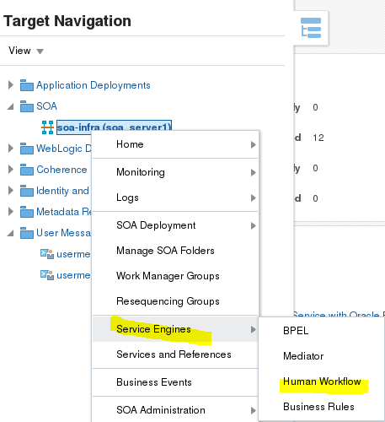

**Send Test notification**

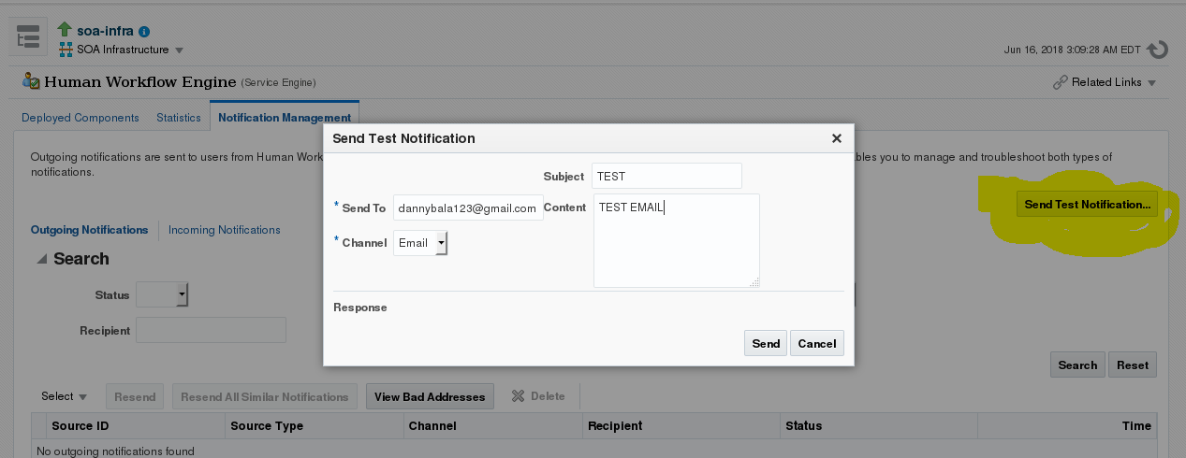

**Error Details**

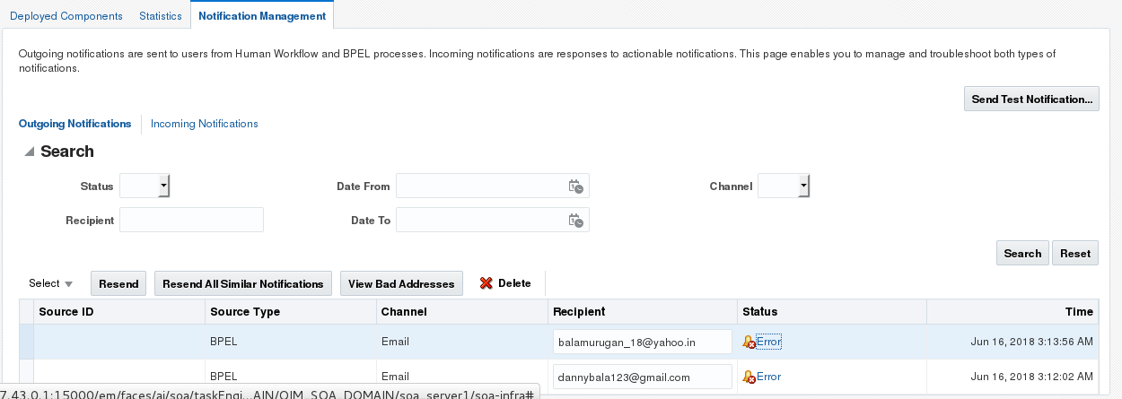

**LOGGING**